Nguyễn Thạc Thắng 20221036

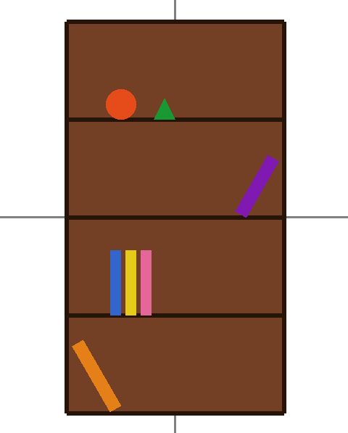

#include "glut.h"
#include "math.h"

void drawAxes() {
glLineWidth(3.0f);

glColor3f(0.5f, 0.5f, 0.5f);

glBegin(GL_LINES);
glVertex2f(-1.0f, 0.0f);
glVertex2f(1.0f, 0.0f);
glEnd();

glBegin(GL_LINES);
glVertex2f(0.0f, -1.0f);
glVertex2f(0.0f, 1.0f);
glEnd();
}

void drawCircle(float cx, float cy, float r, int num_segments) {
glBegin(GL_POLYGON);
for (int i = 0; i < num_segments; i++) {
float theta = 2.0f * 3.1415926f * float(i) / float(num_segments);
float x = r * cosf(theta);
float y = r * sinf(theta);
glVertex2f(x + cx, y + cy);
}
glEnd();
}

void drawBookshelf() {
glColor3f(0.45f, 0.25f, 0.15f);
glBegin(GL_QUADS);
glVertex2f(-0.5f, -0.9f);
glVertex2f(0.5f, -0.9f);
glVertex2f(0.5f, 0.9f);
glVertex2f(-0.5f, 0.9f);
glEnd();

glColor3f(0.15f, 0.08f, 0.03f);
glLineWidth(6);
glBegin(GL_LINE_LOOP);
glVertex2f(-0.5f, -0.9f);
glVertex2f(0.5f, -0.9f);
glVertex2f(0.5f, 0.9f);
glVertex2f(-0.5f, 0.9f);
glEnd();

for (int i = -1; i <= 3; ++i) {
float y = -0.9f + i * 0.45f;
glBegin(GL_LINES);
glVertex2f(-0.5f, y);
glVertex2f(0.5f, y);
glEnd();
}

glColor3f(0.9f, 0.3f, 0.1f);
drawCircle(-0.25f, 0.45f + 0.07f, 0.07f, 100);

glColor3f(0.1f, 0.6f, 0.2f);
glBegin(GL_TRIANGLES);
glVertex2f(-0.1f, 0.45f);
glVertex2f(-0.05f, 0.55f);
glVertex2f(0.0f, 0.45f);
glEnd();

glPushMatrix();
glTranslatef(0.35f, 0.0f + 0.1f, 0.0f);
glRotatef(-30.0f, 0, 0, 1);
glColor3f(0.5f, 0.1f, 0.7f);
glBegin(GL_QUADS);
glVertex2f(-0.03f, -0.1f);
glVertex2f(0.03f, -0.1f);
glVertex2f(0.03f, 0.2f);
glVertex2f(-0.03f, 0.2f);
glEnd();
glPopMatrix();

for (int i = 0; i < 3; ++i) {
float x = -0.3f + i * 0.07f;
if (i == 0) glColor3f(0.2f, 0.4f, 0.8f);
else if (i == 1) glColor3f(0.9f, 0.8f, 0.1f);
else glColor3f(0.9f, 0.4f, 0.6f);

glBegin(GL_QUADS);
glVertex2f(x, -0.45f);
glVertex2f(x + 0.05f, -0.45f);
glVertex2f(x + 0.05f, -0.45f + 0.3f);
glVertex2f(x, -0.45f + 0.3f);
glEnd();
}

glPushMatrix();
glTranslatef(-0.35f, -0.9f + 0.15f, 0.0f);
glRotatef(30.0f, 0, 0, 1);
glColor3f(0.9f, 0.5f, 0.1f);
glBegin(GL_QUADS);
glVertex2f(-0.03f, -0.15f);
glVertex2f(0.03f, -0.15f);
glVertex2f(0.03f, 0.2f);
glVertex2f(-0.03f, 0.2f);
glEnd();
glPopMatrix();
}

void display() {
glClear(GL_COLOR_BUFFER_BIT);
drawAxes();
drawBookshelf();
glFlush();
}

void init() {
glClearColor(1.0, 1.0, 1.0, 1.0);
glMatrixMode(GL_PROJECTION);
glLoadIdentity();
gluOrtho2D(-1, 1, -1, 1);
}

int main(int argc, char** argv) {
glutInit(&argc, argv);
glutInitDisplayMode(GLUT_SINGLE | GLUT_RGB);
glutInitWindowSize(600, 600);
glutCreateWindow("Gia sach");
init();
glutDisplayFunc(display);
glutMainLoop();
return 0;
}

